+233 59 287 3066

emmanuelaforo5@gmail.com

linkedin.com/in/emmanuel-aforo

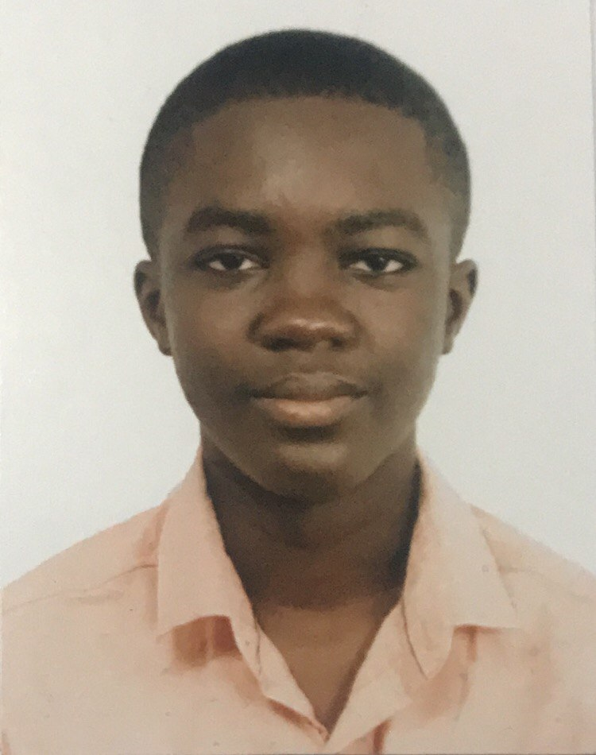

Emmanuel Aforo

## Skills

* Web Development
* Graphic Design
* Front end development
* Creative design
* Innovative
* Team player
* Exceptional communication skills

## Education

**SHS Student**

General Arts | 2023- 2025

**Presbyterian Boys' Secondary School, Legon**, Legon - Accra

## Additional

Programming Languages: JavaScript, HTML5, CSS, Python

Hobbies & Interests: Coding, Graphic Design, Video Editing & Content Management

## Summary

Enthusiastic IT learner skilled in HTML, CSS, Bootstrap, and driven to excel in JavaScript and Python for web development. Proficient in Canva and Photoshop for graphic design, with a solid year of diverse tech experience. Completed projects include a school website and blog, showcasing a well-rounded skill set and a genuine passion for technology.

## Experience

**Home IT Assistant- 01/2020 to Present**

**Davinci Multimedia, Taifa - Accra**

* Assisted and learned from an experienced IT specialist (my father) in computer building, troubleshooting, and various technical tasks.

**Church Media Team Contributor** – 09/2022 to Present

**Charismatic Baptist Church, Taifa - Accra**

* Engaged hands-on experience within my church’s media team, contributing to tasks such as video editing, graphic design, and technical support for events